- WIND ENERGY- AN OVERVIEW

1.1 Definition of wind:
Wind can be defined simply as air in motion. This motion can be in any direction, but in most cases the horizontal component of wind flow greatly exceeds the flow that occurs vertically.

1.2 Wind Energy and Wind Power:
Wind is a form of solar energy. Winds are caused by the uneven heating of the atmosphere by the sun, the irregularities of the earth's surface, and rotation of the earth. Wind flow patterns are modified by the earth's terrain, bodies of water, and vegetative cover. This wind flow, or motion energy, when "harvested" by modern wind turbines, can be used to generate electricity.
1.3 Renewable energy:
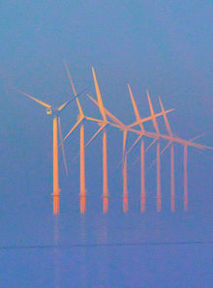
Fig 1.1. Diagram Of Renewable Energy Source

Renewable energy is energy which comes from natural resources such as sunlight, wind, rain, tides, and geothermal heat, which are renewable (naturally replenished). In 2008, about 19% of global final energy consumption came from renewable, with 13% coming from traditional biomass, which is mainly used for heating, and 3.2% from hydroelectricity. New renewable (small hydro, modern biomass, wind, solar, geothermal, and befouls) accounted for another 2.7% and are growing very rapidly. The share of renewable in electricity generation is around 18%, with 15% of global electricity coming from hydroelectricity and 3% from new renewable. While many renewable energy projects are large-scale, renewable technologies are also suited to rural and remote areas, where energy is often crucial in human development. Globally, an estimated 3 million households get power from small solar PV systems. Micro-hydro systems configured into village-scale or county-scale mini-grids serve many areas. More than 30 million rural households get lighting and cooking from biogas made in household-scale digesters. Biomass cook stoves are used by 160 million households. Climate change concerns, coupled with high oil prices, peak oil, and increasing government support, are driving increasing renewable energy legislation, incentives and commercialization. New government spending, regulation and policies helped the industry weather the global financial crisis better than many other sectors.

1.4 Overview:
Renewable energy flows involve natural phenomena such as sunlight, wind, tides, plant growth, and geothermal heat, as the International Energy Agency explains Renewable energy is derived from natural processes that are replenished constantly. In its various forms, it derives directly from the sun, or from heat generated deep within the earth. Included in the definition is electricity and heat generated from solar, wind, ocean, hydropower, biomass, geothermal resources, and bio fuels and hydrogen derived from renewable resources.
      - Power generation: Renewable energy provides 18 percent of total electricity generation worldwide. Renewable power generators are spread across many countries, and wind power alone already provides a significant share of electricity in some areas: for example, 14 percent in the U.S. state of Iowa, 40 percent in the northern German state of Schleswig-Holstein, and 20 percent in Denmark. Some countries get most of their power from renewable, including Iceland (100 percent), Brazil (85 percent), Austria (62 percent), New Zealand (65 percent), and Sweden (54 percent).
      - Heating: Solar hot water makes an important contribution in many countries, most notably in China, which now has 70 percent of the global total (180 GWth). Most of these systems are installed on multi-family apartment buildings and meet a portion of the hot water needs of an estimated 50–60 million households in China. Worldwide, total installed solar water heating systems meet a portion of the water heating needs of over 70 million households. The use of biomass for heating continues to grow as well. In Sweden, national use of biomass energy has surpassed that of oil. Direct geothermal for heating is also growing rapidly.
      - Transport fuels: Renewable befouls have contributed to a significant decline in oil consumption in the United States since 2006. The 93 billion liters of befouls produced worldwide in 2009 displaced the equivalent of an estimated 68 billion liters of gasoline, equal to about 5 percent of world gasoline production.

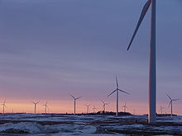
Fig1.2. Wind Power Market
At the end of 2009, worldwide wind farm capacity was 159,213 MW representing an increase of 31 percent during the year and wind power supplied some 1.3% of global electricity consumption. Wind power accounts for approximately 19% of electricity use in Denmark, 9% in Spain. Renewable energy can be particularly suitable developing countries. In rural and remote areas, transmission and distribution of energy generated from fossil fuels can be difficult and expensive. Producing renewable energy locally can offer a viable alternative.

2. LITERATURE SURVEY
Z. Lubosny presents the impact of wind turbine generation systems operation connected to power systems in 2003, and describes the main power quality parameters and requirements on such generations. Furthermore, it deals with the complexities of modeling wind turbine generation systems connected to the power grid, i.e. modeling of electrical, mechanical and aerodynamic components of the wind turbine system, including the active and reactive power control. In order to analyze power quality phenomena related to wind power generation, digital computer simulation is required to solve the complex differential equations. Other important factors analyzed in this paper are grid connection requirements for connecting large wind farms to the power grid, specified by system operators all over Europe. The requirements, which include voltage and frequency stability, the ability to supply reactive power and responses to fault conditions, and active power control and power factor, are compared by the most important European wind power producers. Finally, a methodology for impact determination is proposed.

J.G. Slootweg, S.W.H. de Haan, H.Polinde and W. L. Kling presented a tendency to erect ever more wind turbines can be observed in order to reduce the environmental consequences of electric power generation in 2003. As a result of this, in the near future, wind turbines may start to influence the behavior of electric power systems by interacting with conventional generation and loads. Therefore, wind turbine models that can be integrated into power system simulation software are needed. In this contribution, a model that can be used to represent all types of variable speed wind turbines in power system dynamics simulations is presented. First, the modeling approach is commented upon and models of the subsystems of which a variable speed wind turbine consists are discussed. Then, some results obtained after incorporation of the model in PSS/E, a widely used power system dynamics simulation software package, are presented and compared with measurements.

P. M. Anderson and A. Bose presents simulation and digital computer modeling effort is described in which a wind turbine generator system is adapted for stability evaluation using a large scale transient stability computer program in 1983 . Component models of the MOD-2 wind generator system are described and their digital model equations are provided. A versatile wind velocity model is described, which provides the capability of simulating a wide variety of wind variations, in addition to the usual network disturbances. Computed results obtained from runs of the enhanced stability program are provided that illustrate the wind turbine-generator system dynamic performance for changes in wind velocity.

M. Yin, G. Li,M. Zhou and C. Zhao presents the dynamic model and control schemes of a variable speed pitch wind turbine with permanent magnet synchronous generator (PMSG) in 2007. The model includes a PMSG model, a pitch-angled controlled wind turbine model and a drive train model. The drive train model uses one-mass model to represent the mechanical characteristics of the generator set. The generator model is established in the d-q synchronous rotating reference frame. The wind turbine model details the mechanism of variable speed operation of the turbine by a pitch control. The control schemes in the paper include a pitch angle control for the wind turbine and a speed control for the generator. The pitch angle control uses wind speeds and electric power output as the input signals to ensure normal operation in high wind speed. The speed control is realized through field orientation where the d-axis current is set to zero and the q-axis current is used to control the rotational speed of the generator according to the variation of wind speed. In order to verify the presented model and the control strategy, simulations with MATLAB/Simulink software have been conducted. Simulation results prove the validity of the model and the control schemes.

- HISTORY OF WIND ENERGY
The wind turbine first came into being as a horizontal axis windmill for mechanical power generation, used since 1000 AD in Persia, Tibet and China. Transfer of mechanical windmill technology from the Middle East to Europe took place between 1100 and 1300, followed by further development of the technology in Europe. During the 19th century many tens of thousands of modem windmills with rotors of 25 meters in diameter were operated in France, Germany and the Netherlands, most of the mechanical power used in industry was based on wind energy. Further diffusion of mechanical windmill technology to the United States took place during the 19th Century. The earliest recorded (traditional) windmill dates from the year 1191 at the Abbey of Bury St Edmunds in Suffolk. It replaced animal power for grinding grain and other farm activities like drawing water from well, the popularity of wind turbines increased tremendously and they soon dotted the landscape.

The advent of DC electric power in 1882, and introduction of 3-phase AC power production in the early 1890s, provided a technological basis for constructing wind turbines that generated electricity. The Danish scientist and engineer Poul La Cour is the most widely known pioneer of electricity generation using wind power. In 1891 in Askov, Denmark he introduced a four shuttle sail rotor design generating approximately 10kW of DC electric power. He also applied the DC current for water electrolysis, and utilized the hydrogen gas for gas lamps to light up the local school grounds. La Cour's efforts started research, development and commercialization of wind electricity in Europe and thus Europe gained its leadership role in wind energy electricity generation.

Though less recognized than La Cour, Charles F. Brush in 1888 introduced in Cleveland Ohio the first automatically operating wind turbine generator, a 12kW, 17-meter-diameter machine, operated for 20 years.

By 1908 there were several wind mills in operation for electricity generation, with capacities ranging from 5-25 kW. By 1930’s wind turbines with capacity of 500kW were developed which found wide spread use in inaccessible areas. With concerns over climate change and depleting and polluting fossil fuels wind power has emerged as the most promising source of renewable energy:
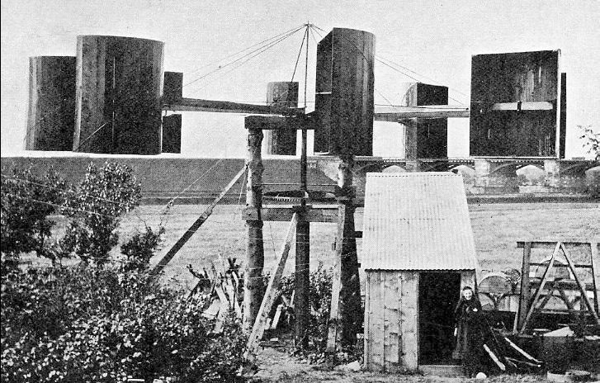

Fig 3.1. James Blyth's 1891 Windmill

3.1 MAJOR FACTORS THAT HAVE ACCELERATED THE WIND-POWER TECHNOLOGY

- Development of high-strength fiber composites for constructing large low-cost blades.

- Reduction in prices of the power electronics components such as converters.

- Variable-speed operation of electrical generators to capture maximum energy.

- Improved plant operation, pushing the availability up to 95 percent.

- Economy of scale, as the turbines and plants are getting larger in size.

- Accumulated field experience (the learning curve effect) improving the capacity factor.

- STATISTICS
Worldwide there are now over two hundred thousand wind turbines operating, with a total nameplate capacity of 282,482 MW as of end 2012. The European Union alone passed some 100,000 MW nameplate capacities in September 2012, while the United States surpassed 50,000 MW in August 2012 and China passed 50,000 MW the same month.
World wind generation capacity more than quadrupled between 2000 and 2006, doubling about every three years. The United States pioneered wind farms and led the world in installed capacity in the 1980s and into the 1990s. In 1997 German installed capacity surpassed the U.S. and led until once again overtaken by the U.S. in 2008. China has been rapidly expanding its wind installations in the late 2000s and passed the U.S. in 2010 to become the world leader.
At the end of 2012, worldwide nameplate capacity of wind-powered generators was 282 Giga watts (GW), growing by 44 GW over the preceding year. According to the World Wind Energy Association, an industry organization, in 2010 wind power generated 430 TWh or about 2.5% of worldwide electricity usage, up from 1.5% in 2008 and 0.1% in 1997. Between 2005 and 2010 the average annual growth in new installations was 27.6 percent. Wind power market penetration is expected to reach 3.35 percent by 2013 and 8 percent by 2018.
Several countries have already achieved relatively high levels of penetration, such as 28% of stationary (grid) electricity production in Denmark (2011) , 19% in Portugal (2011), 16% in Spain (2011), 14% in Ireland (2010) and 8% in Germany (2011). As of 2011, 83 countries around the world were using wind power on a commercial basis.
Europe accounted for 48% of the world total wind power generation capacity in 2009. In 2010, Spain became Europe's leading producer of wind energy, achieving 42,976 GWh. Germany held the top spot in Europe in terms of installed capacity, with a total of 27,215 MW as of 31 December 2010.

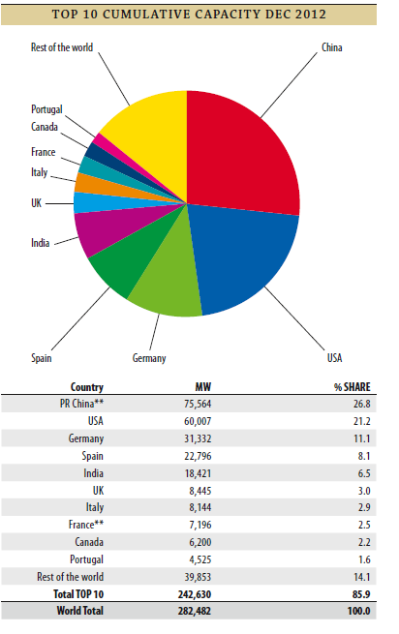
Fig 4.1. Worldwide Wind Energy Statistics Up To December 2012

- WIND TURBINES
5.1 Principles of wind turbines:
A wind turbine is a rotating machine which converts the wind kinetic energy into mechanical energy. If the mechanical energy is then converted to electricity, the machine is called a wind generator, wind turbine.
Wind turbines can be separated into two types based by the axis in which the turbine rotates as Horizontal Axis Wind Turbines and Vertical Axis Wind Turbines. The former are more commonly used due to several inherent advantages, the latter being used in small scale.

Fig 5.1. Wind Turbine Principle Operation
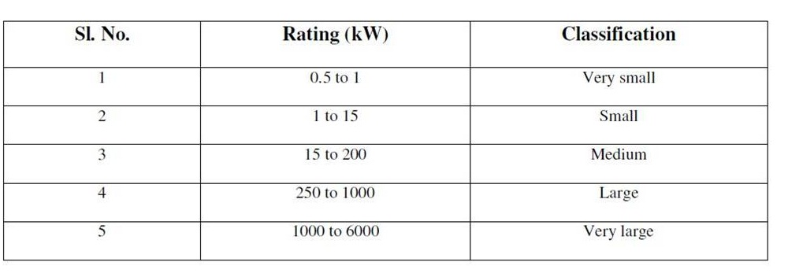Table 5.1. Classification Of Wind Turbines

5.2 Internal components of a wind turbine:

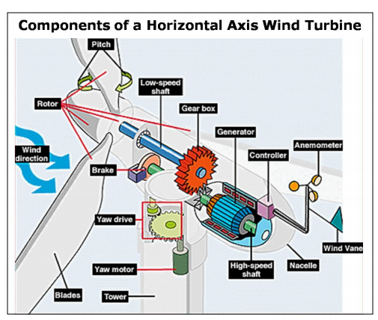
Fig 5.2. Internal Parts Of Wind Turbine
- Blades: These are aerodynamically designed structures such that when wind flows over them they are lifted as in airplane wings. The blades are also slightly turned for greater aerodynamic efficiency.

- Rotor: The hub and the blades together compose the rotor.

- Pitch: This is basically angle of the blades make with the wind. Changing the pitch angle changes weather the blades turn in or turn out of the wind stream.

- Brake: This is either a mechanical, electrical or hydraulic brake used for stopping the turbine in high wind conditions.

- Low-speed shaft: The rotor turns the low-speed shaft at about 30 to 60 rotations per minute.

- Gear box: this step-up or steps down the speed of turbine and with suitable coupling transmits rotating mechanical energy at a suitable speed to the generator. Typically a gear box system steps up rotation speed from 50 to 60 rpm to 1200 to 1500 rpm

- Generator: This can be a synchronous or asynchronous Ac machine producing power at 50Hz

- Controller: This is the most important part of the turbine as it controls everything from power output to pitch angle. The controller senses wind speed, wind direction, shaft speed and torque at one or more points. Also the temp of generator and power output produced is sensed.

- Anemometer: This device is used for measurement of speed. The wind speed is also fed to the controller as it is one of the variables for controlling pitch angle and yaw.

- Wind vane: Basically the job of a wind sensor, measuring the wind speed and communicating the same to the yaw drive, so as to turn the turbine into the wind flow direction.

- Nacelle: The nacelle is the housing structure for high speed shaft, low speed shaft, gear box, generator, converter equipment etc. It is located atop the tower structure mostly in the shadow of the blades.

- High-speed shaft: Its function is to drive the generator.

- Yaw drive: This drive controls the orientation of the blades towards the wind. In case the turbine is out of the wind, then the yaw drive rotates the turbine in the wind direction.

- Yaw motor: Powers the yaw drive.

- Tower: Towers are basically made up of tubular steel or steel lattice. Taller the towers greater is the amount of power generated as the wind speed generally goes on increasing with height.

5.3 Types of Wind Turbine:
Wind turbines can be classified into two basic types
5.3.1 Horizontal axis wind turbine
5.3.2 Vertical axis wind turbine

5.3.1 Horizontal Axis Wind Turbines (HAWTs):
Fig 5.3. Horizontal Axis Wind Turbine

Horizontal-axis wind turbines (HAWT) get their name from the fact that their axis of rotation is horizontal. They have the main rotor shaft and electrical generator at the top of a tower, and are pointed into the wind. The variability of wind distribution and speed brings up the requirement of a gear system connected to the rotor and the generator. The gear system enables a constant speed of rotation to the generator thus enabling constant frequency generation. Turbine blades are made stiff in order to prevent the blades from being pushed into the tower by high winds. Downwind machines have also been built, as they no longer require a yaw mechanism to keep them facing the wind, and also because in high winds the blades can turn out of the wind thereby increasing drag and coming to a stop. Most of the HAWTs’ are upwind as downwind systems cause regular turbulence which may lead to fatigue.

HAWT advantages
- Variable blade pitch, which gives the turbine blades the optimum angle of attack. Changing the angle of attack provides greater control over power generated and enables maximum efficiency.
- As wind energy increases with height, the tall tower in the HAWT gives access to higher wind speed. In some cases increase of even 10m height leads to increase in wind speed by 20 %
- In HAWTs’ the blades move horizontally that is perpendicular to the wind and hence has minimum drag and they receive power throughout the rotation.

HAWT disadvantages
- Due to inherent large structures, construction costs are very high and transportation costs are also high.
- Civil construction is costly due to erection of large towers.
- Wind turbine operation often leads to production of electronic noise which affects radar
- In case of downwind HAWTs’ the regular turbulence produced leads to structural
- HAWTs require an additional yaw control mechanism to turn the blades toward the wind.
Types of HAWTs:
- Mono-Blade Horizontal Axis Wind Turbine (HAWT)

Features:
- They have lighter rotor and are cheaper.
- Blade are 15-25 m long and are made up of metal, glass reinforced plastics, laminated wood, composite carbon fiber/ fiberglass etc.
- Power generation is within the range 15 kW to 50 kW and service life of plant is 30 years.

Advantages:
- Simple and lighter construction.
- Favorable price
- Easy to install and maintain.
Disadvantages:
- Tethering control necessary for higher loads.
- Not suitable for higher power ratings.
Applications:
- Field irrigation
- Sea-Water desalination Plants
- Electric power supply for farms and remote loads.

- Twin-Blade HAWT

- They have large sizes and power output in range of 1 MW, 2 MW and 3MW.
- These high power units feed directly to the distribution network.

- 3-Blade HAWT

- Three blade propeller type wind turbines have been installed in India as well as abroad.
- The rotor has three blades assembled on a hub. The blade tips have a pitch control of 0 – 30 for controlling shaft speed.
- The shaft is mounted on bearings.
- The gear chain changes the speed from turbine shaft to generator shaft.

5.3.2 Vertical Axis Wind Turbines (VAWTs)
Vertical-axis wind turbines (or VAWTs) have the main rotor shaft arranged vertically as the plane of rotation is vertical. Blades are also vertical in this arrangement. The biggest advantage of VAWTs is they don’t require a yaw control mechanism to be pointed into the wind. Thus these are useful in sites where wind direction is random or there is presence of large obstacles like trees, houses etc. Also VAWTs’ don’t require a tower structure and can be placed nearby a ground enabling access to electrical components. Some drawbacks are the low efficiency of wind production and the fact that large drag is created for rotating the blades in a vertical axis.

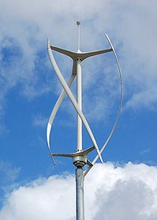
Fig 5.4. Vertical Axis Wind Turbine

VAWT advantages
- A massive tower structure is not required, as VAWTs’ are mounted closer to the ground
- They don’t require yaw mechanisms.
- These are located closer to the ground and hence easier to maintain.
- These have lower startup speeds than their horizontal counterparts. These can start at speeds as low as 10Kmph.
- These have a lower noise signature.

VAWT disadvantages
- VAWTs’ have lower efficiency as compared to HAWTs’ because of the additional drag produced due to rotation of blades.
- Even though VAWTs’ are located closer to the ground, the equipment now resides at the bottom of the turbines structure thus making it inaccessible.
- Because of their low height they cannot capture the wind energy stored in higher altitudes.

Types of VAWTs

- Persian Windmill:
- The Persian windmill was the earliest windmill installed.
- It is a vertical axis windmill.
- This windmill was used to grind grains and make flour.
- Savonius Rotor VAWT:
- Patented by S.J. Savonius in 1929.
- It is used to measure wind current.
- Efficiency is 31%.
- It is Omni-directional and is therefore useful for places where wind changes direction frequently.

- Darrieus Rotor VAWT:
- It consists of 2 or 3 convex blades with airfoil cross-section.
- The blades are mounted symmetrically on a vertical shaft.
- To control speed of rotation mechanical brakes are incorporated. Those brakes consist of steel discs and spring applied air released calipers for each disc.

5.4 Wind Turbine Topologies:
There are a large number of choices of topologies available to the designer of a wind turbine and, over the years, most of these have been explored. However, commercial designs for electricity generation have now converged to horizontal axis, three-bladed, upwind turbines. The largest machines tend to operate at variable speed whereas smaller, simpler turbines are of fixed speed. For a fixed-speed system the turbulence of the wind will result in power variations, and thus affect the power quality of the grid where as in a variable-speed wind turbine the generator is controlled by power electronic equipment, which makes it possible to control the rotor speed. In this way the power fluctuations caused by wind variations can be more or less absorbed by changing the rotor speed and thus power variations originating from the wind conversion and the drive train can be reduced. Hence, the power quality impact caused by the wind turbine can be improved compared to a fixedspeed turbine.
Modern electricity generating wind turbines now use three-bladed upwind rotors, although two bladed, and even one-bladed, rotors were used in earlier commercial turbines. Reducing the number of blades means that the rotor has to operate at a higher rotational speed in order to extract the wind energy passing through the rotor disk. Although a high rotor speed is attractive in that it reduces the gearbox ratio required, a high blade tip speed leads to increased aerodynamic noise and increased blade drag losses. Most importantly, three-bladed rotors are visually more pleasing than other designs and so these are now always used on large electricity generating turbines.

5.4.1 Fixed speed wind turbine (Type A):

This type of turbines are also called Type A turbine. Fixed-speed wind turbines are electrically fairly simple devices consisting of an aerodynamic rotor driving a low-speed shaft, a gearbox, a high-speed shaft and an induction (sometimes known as asynchronous) generator. From the electrical system viewpoint they are perhaps best considered as large fan drives with torque applied to the low-speed shaft from the wind flow. Fig 5.4.1 illustrates the configuration of a fixed-speed wind turbine. It consists of a squirrel-cage induction generator coupled to the power system through a turbine transformer. The generator operating slip changes slightly as the operating power level changes and the rotational speed is therefore not entirely constant. However, because the operating slip variation is generally less than 1%, this type of wind generation is normally referred to as fixed speed.
Squirrel-cage induction machines consume reactive power and so it is conventional to provide power factor correction capacitors at each wind turbine. The function of the soft-starter unit is to build up the magnetic flux slowly and so minimize transient currents during energization of the generator. Also, by applying the network voltage slowly to the generator, once energized, it brings the drive train slowly to its operating rotational speed.
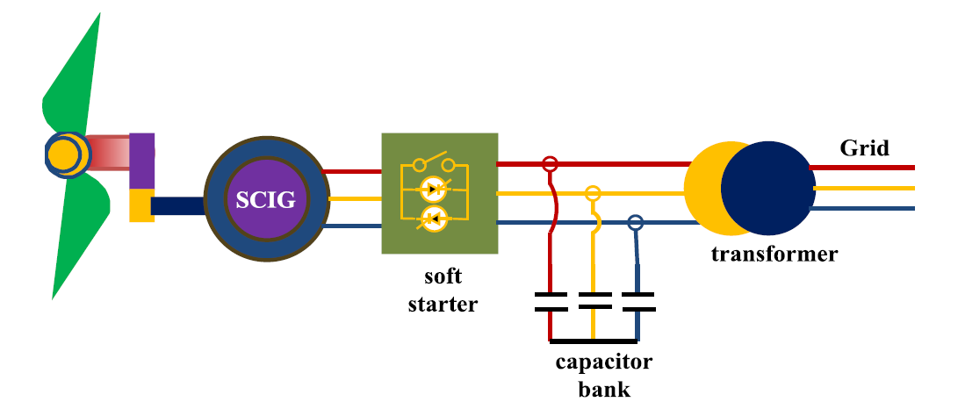
Fig 5.5. Schematic Diagram Of A Fixed Speed Wind Turbine

5.4.2 Variable speed wind turbine:
During the past few years the variable-speed wind turbine has become the dominant type among the installed wind turbines. Variable-speed wind turbines are designed to achieve maximum aerodynamic efficiency over a wide range of wind speeds. With a variable-speed operation it has become possible continuously to adapt (accelerate or decelerate) the rotational speed ω of the wind turbine to the wind speed V∞. This way, the tip speed ratio λ is kept constant at a predefined value that corresponds to the maximum power coefficient. Contrary to a fixed-speed system, a variable-speed system keeps the generator torque fairly constant and the variations in wind are absorbed by changes in the generator speed. The electrical system of a variable-speed wind turbine is more complicated than that of a fixed-speed wind turbine. It is typically equipped with an induction or synchronous generator and connected to the grid through a power converter. The power converter controls the generator speed; that is, the power fluctuations caused by wind variations are absorbed mainly by changes in the rotor generator speed and consequently in the wind turbine rotor speed. The advantages of variable-speed wind turbines are an increased energy capture, improved power quality and reduced mechanical stress on the wind turbine. The disadvantages are losses in power electronics, the use of more components and the increased cost of equipment because of the power electronics. The introduction of variable-speed wind-turbine types increases the number of applicable generator types and also introduces several degrees of freedom in the combination of generator type and power converter type.
Most common variable speed wind turbine configurations are as follows.

5.4.2.1 Type B wind turbine:
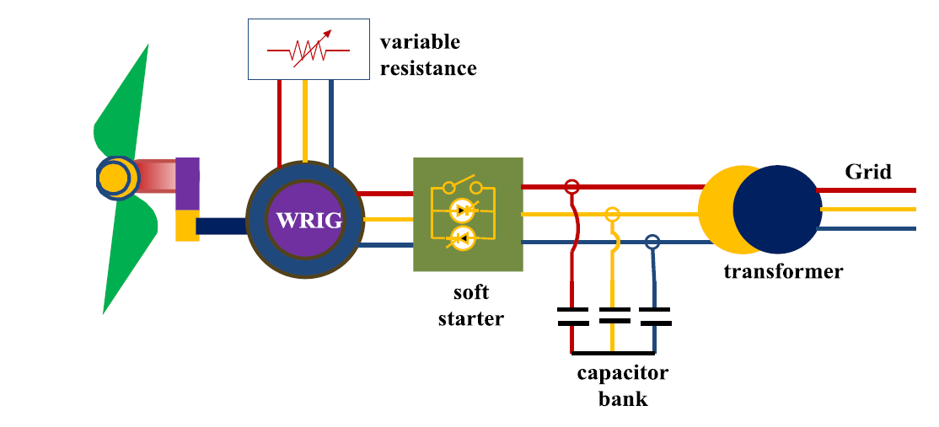
Fig 5.6. Schematic Diagram Of Type B Wind Turbine

This configuration corresponds to the limited variable speed wind turbine with variable generator rotor resistance. It uses a wound rotor induction generator (WRIG) and has been used by the Danish manufacturer Vestas since mid nineties. The generator is directly connected to the grid. A capacitor bank performs the reactive power compensation. A smoother grid connection is achieved by using a soft-starter. The unique feature of this concept is that it has a variable additional rotor resistance, which can be changed by an optically controlled converter mounted on the rotor shaft. Thus, the total rotor resistance is controllable. This optical coupling eliminates the need for costly slip rings that need brushes and maintenance. The rotor resistance can be changed and thus controls the slip. This way, the power output in the system is controlled. The range of the dynamic speed control depends on the size of the variable rotor resistance. Typically, the speed range is 0 to10% above synchronous speed. The energy coming from the external power conversion unit is dumped as heat loss. Wallace and Oliver (1998) describe an alternative concept using passive components instead of a power electronic converter. This concept achieves a 10% slip, but it does not support a controllable slip. Fig ## shows the schematic diagram of type B wind turbine.

5.4.2.2 Type C wind turbine:
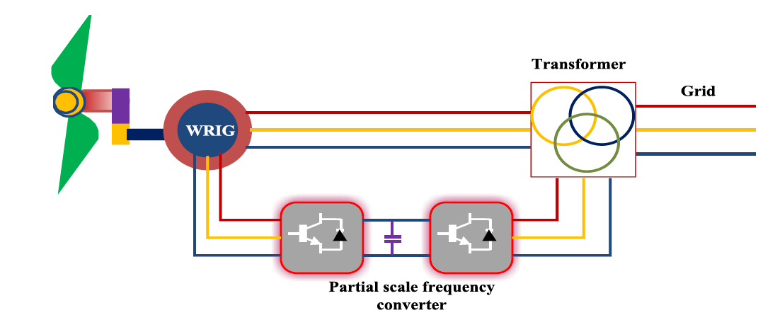
Fig 5.7. Schematic diagram of Type C wind turbine
This configuration, known as DFIG based wind turbine, corresponds to the limited variable speed wind turbine with a WRIG and partial scale frequency converter (rated at approximately 30% of nominal generator power) on the rotor circuit. The partial scale frequency converter performs the reactive power compensation and the smoother grid connection. It has a wider range of dynamic speed control compared with that of Type B wind turbine, depending on the size of the frequency converter. Typically, the speed range comprises synchronous speed -40% to +30 %. The smaller frequency converter makes this concept attractive from an economical point of view. Its main drawbacks are the use of slip rings and protection in the case of grid faults. The schematic diagram is shown in Fig 5.4.2.2.

5.4.2.3 Type D wind turbine:

This configuration corresponds to the full variable speed wind turbine, with the generator connected to the grid through a full-scale frequency converter. The frequency converter performs the reactive power compensation and the smoother grid connection. The generator can be excited electrically (WRSG/WRIG) or by a permanent magnet (PMSG). Some full variable-speed wind turbine systems have no gearbox. In these cases, a direct driven multi pole generator with a large diameter is used. The wind turbine companies Enercon, Made and Lagerwey are examples of manufacturers using this configuration. The schematic configuration is shown in Fig 5.4.2.3.
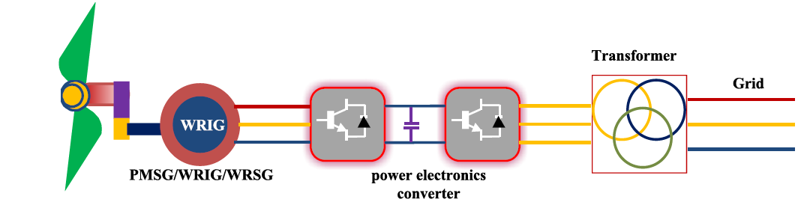
Fig 5.8. Schematic diagram of Type D wind turbine
Well we use Type D turbine in our project to obtain the wind modeling and characteristics.

- WIND FARMS
There are mainly two types of wind farms, they are:
6.1 Off shore wind farms:
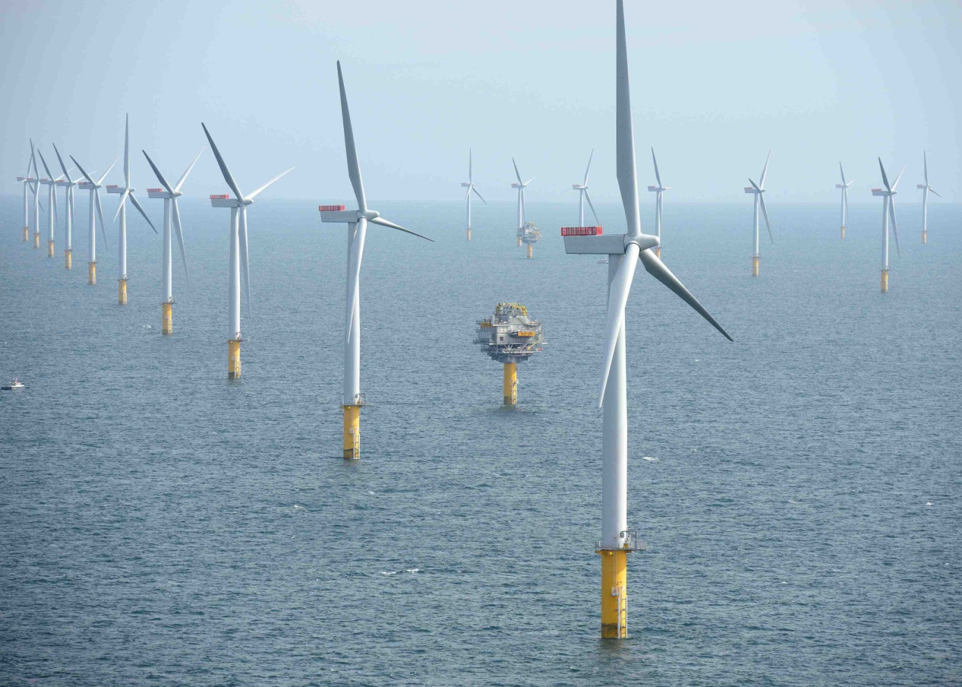
Fig 6.1. Diagram Of Off Shore Wind Farm
Offshore wind power refers to the construction of wind farms in bodies of water to generate electricity from wind. Better wind speeds are available offshore compared to on land, so offshore wind power’s contribution in terms of electricity supplied is higher. Siemens and Vestas are the leading turbine suppliers for offshore wind power. Dong Energy, Vattenfall and E. on are the leading offshore operators.[ As of October 2010, 3.16 GW of offshore wind power capacity was operational, mainly in Northern Europe. According to BTM Consult, more than 16 GW of additional capacity will be installed before the end of 2014 and the United Kingdom and Germany will become the two leading markets. Offshore wind power capacity is expected to reach a total of 75 GW worldwide by 2020, with significant contributions from China and the United States.

6.2 On shore wind farms:
CPRE believes that climate change caused by greenhouse gas emissions is a major threat to the global environment and to the character and quality of England’s country side. We are therefore campaigning for urgent reductions in energy consumption, especially through improved transport policies and better planning and design of new development .We recognize too, the need for improved energy efficiency and the need to exploit the potential of a range of renewable energy sources, including wind power, to reduce greenhouse gas emissions. However, the visual impact of large wind turbines can be a form of pollution which damages the landscape. Decisions on the scale and location of wind power development and other forms of energy generation should therefore avoid damaging valued rural landscapes – not only those that are designated as National Parks or AONBs. Landscape character assessment should be used to identify broad locations which may be appropriate for renewable energy development and those where unacceptable harm would be done to the landscape. While CPRE will support renewable energy development in certain cases, such schemes should not come at the expense of the countryside. We believe that each wind power proposal should be assessed for its potential impact on the land scope. And we will strongly resist those, which damage the beauty, Tran quality and diversity of the English countryside.
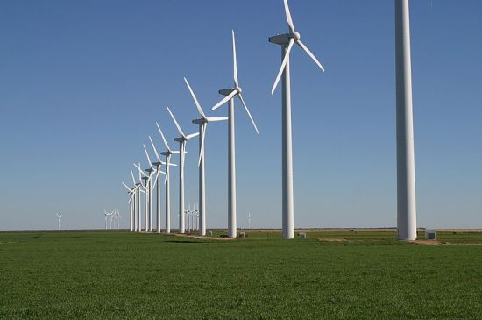
Fig 6.2. Diagram Of On Shore Wind Farm
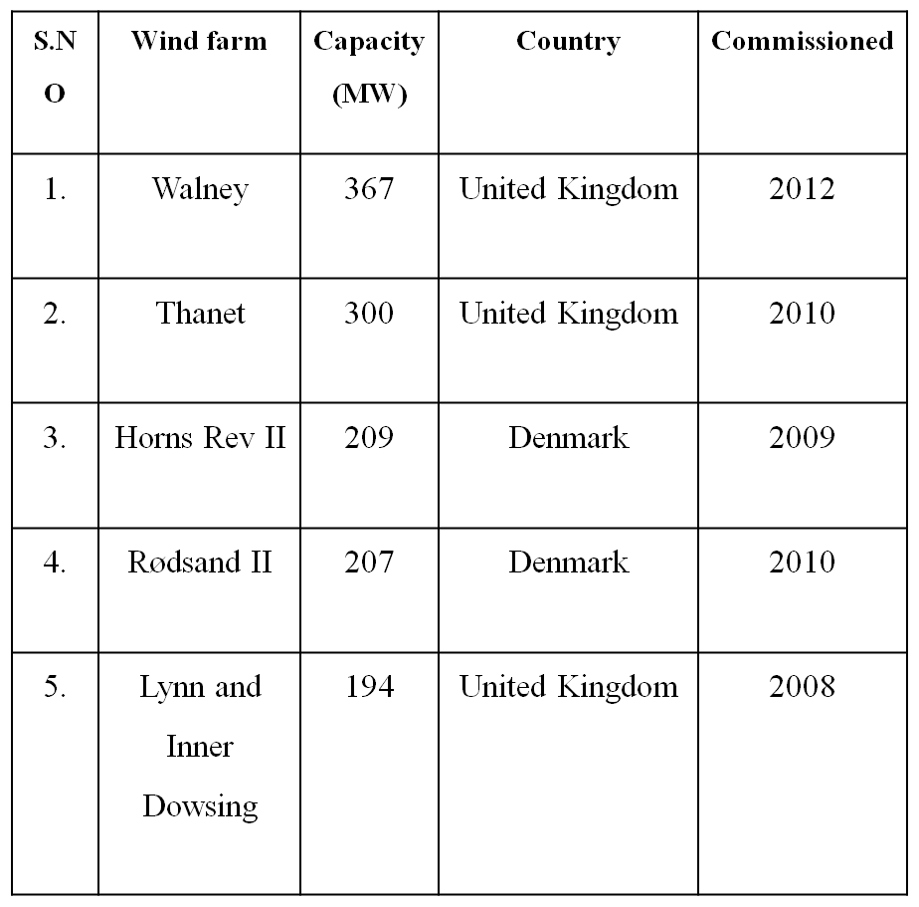
Table 6.1. World’s Largest Off Shore Wind Farms

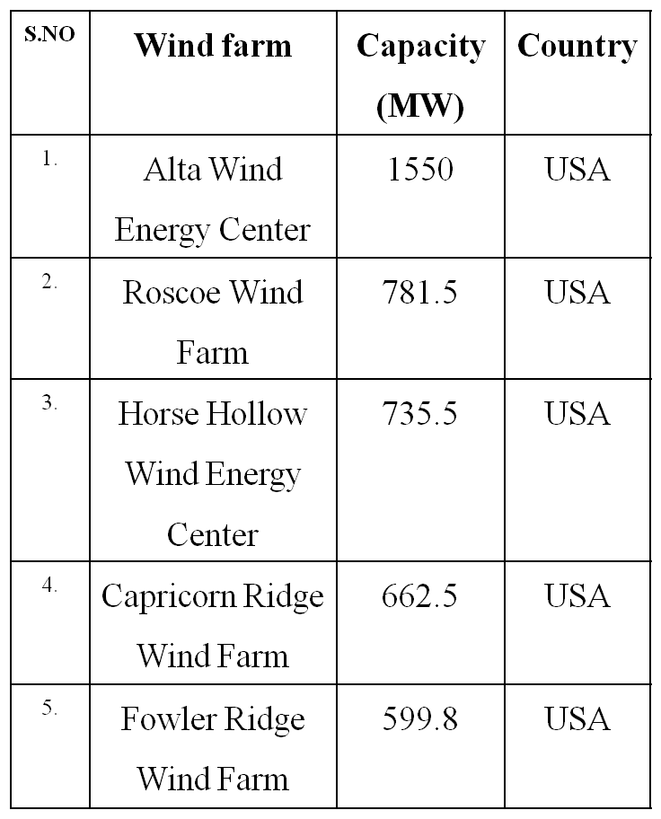
Table 6.2. World’s Largest On Shore Wind Farms

- MATLAB/SIMULINK MODEL

7.1 Introduction about MATLAB:
MATLAB® is a high-performance language for technical computing. It integrates computation, visualization, and programming in an easy-to-use environment where problems and solutions are expressed in a familiar mathematical notation. Typical uses include:
- Math and computation;
- Algorithm development;
- Data acquisition;
- Modeling, simulation, and prototyping;
- Data analysis, exploration, and visualization;
- Scientific and engineering graphics;
- Application development, including graphical user interface building.

The MATLAB system consists of five main parts
- Development Environment: This is the set of tools and facilities that help you use MATLAB functions and files. Many of these tools are graphical user interfaces. It includes the MATLAB desktop and Command Window, a command history, an editor and debugger, and browsers for viewing help, the workspace, files, and the search path.

- MATLAB Mathematical Function Library: This is a vast collection of computational algorithms ranging from elementary functions like sum, sine, cosine, and complex arithmetic, to more sophisticated functions like matrix inverse, matrix Eigen values, Bessel functions, and fast Fourier transforms.

- MATLAB Language: This is a high-level matrix/array language with control flow statements, functions, data structures, input/output, and object-oriented programming features. It allows both "programming in the small" to rapidly create quick and dirty throw-away programs, and "programming in the large" to create complete large and complex application programs.

- Graphics: MATLAB has extensive facilities for displaying vectors and matrices as graphs, as well as annotating and printing these graphs. It includes high-level functions for two-dimensional and three-dimensional data visualization, image processing, animation, and presentation graphics. It also includes low-level functions that allow you to fully customize the appearance of graphics as well as to build complete graphical user interfaces on your MATLAB applications.

- MATLAB Application Program Interface (API): This is a library that allows writing C and FORTRAN programs that interact with MATLAB. It includes facilities for calling routines from MATLAB (dynamic linking), calling MATLAB as a computational engine, and for reading and writing MAT-files.

7.2 Introduction about SIMULINK:
In the last few years, Simulink® has become the most widely used software package in academia and industry for modeling and simulating dynamic systems.

Simulink® is a graphical software package for modeling, simulating, and analyzing dynamic systems and it is based on MATLAB®. It supports linear and nonlinear systems, modeled in continuous time, sampled time, or a hybrid of the two. Systems can also be multi rate, i.e., have different parts that are sampled or updated at different rates. For modeling, Simulink provides a graphical user interface (GUI) for building models as block diagrams, using click-and-drag mouse operations. With this interface, the desired dynamic systems can be easily built. Simulink includes a comprehensive block library of sinks, sources, linear and nonlinear components, and connectors. Using S-Functions it is also possible to customize and create user-defined blocks. Models are hierarchical, so the models can be built using both top-down and bottom-up approaches. The system can be viewed at a high level, then double-click blocks to go down through the levels to see increasing levels of model detail. This approach provides insight into how a model is organized and how its parts interact. After defining a model, it can be simulated, using a choice of integration methods, either from the Simulink menus or by entering commands in the MATLAB Command Window. The menus are particularly convenient for interactive work, while the command-line approach is very useful for running a batch of simulations (e.g. Monte Carlo simulations or sweeping a parameter across a range of values). Using scopes and other display blocks, the simulation results can be analyzed while the simulation is running. In addition, the parameters can be changed during the simulation for "what if" exploration. The simulation results can be put in the MATLAB workspace for post processing and visualization. Model analysis tools include linearization and trimming tools, which can be accessed from the MATLAB command line, plus the many tools in MATLAB and its application toolboxes. Since MATLAB and Simulink are integrated, the models can be simulated, analyzed, and revisited in either environment at any point.

7.3 Simulink Model Of Wind Speed
A model is required that can properly simulate the spatial effect of wind behavior, including gusting, rapid (ramp) changes, and background noise. The wind speed is modeled as the sum of the four components listed below,

Where V_{b} is the base (constant) wind component, V_{r} is the ramp wind component, v_{g} is the gust wind component and V_{n} is the base noise wind component, all of them in m/s. Fig. Shows the graphics of the non-constant wind speed components: ramp, gust and noise components.

Fig 7.1. Non-Constant Wind Speed Components

The present work considers a constant wind speed equal to12 m/s. Consequently, the model implementation of the wind speed in Simulink implies the consideration of the base wind speed component, as shown in Fig.7.2

Fig 7.2. Wind Speed Model With Simulink

- WIND TURBINE MODELING

8.1 Design of the Wind Turbine Rotor:
There are several parameters involved in the design of an efficient yet economical wind turbine. Generally and efficient design of the blade is known to maximize the lift and minimize the drag on the blade. Now, minimization of the drag means that the aerofoil should face the relative wind in such a way that minimum possible area is exposed to the drag force of the wind. Furthermore the angle of this relative wind to the blades is determined by the relative magnitudes of the wind speed and the blade velocity. The thing to note here is that the wind velocity basically stays constant throughout the swept area but the blade velocity increases from the inner edge to the tip. Which means the relative angle of the wind with respect to the blade is ever-changing.
Now the various parameters which determine the design of the wind turbine are noted below:

Diameter of the Rotor:
Since the power generated is directly proportional to the square of the diameter of the rotor, it becomes a valuable parameter. It’s basically determined by the relation between the optimum power required to be generated and the mean wind speed of the area.
Power generated,
P=η_{e}η_{m}c_{p}p₀
=1/2ηeηmC_{p} AρV_{w}³ here, η_{e}= efficiency of electrical generation
=1/8η_{e}η_{m}c_{p}π ρ V_{w}³D² η_{m}= efficiency of mechanical transmission
In the absence of concrete data, the following empirical formulae can be used:
P=0.15 V_{w}³D², for slow rotors ;
0.20 V³D² , for faster rotors.

Choice of the number of blades:
The choice of the number of blades of a wind rotor is critical to its construction as well as operation. Greater number of blades is known to create turbulence in the system, and a lesser number wouldn’t be capable enough to capture the optimum amount of wind energy. Hence the number of blades should be determined by both these constraints and after proper study of its dependence on the TSR. Now, let ta be the time taken by one blade to move into the position previously occupied by the previous blade, so for an n-bladed rotor rotating at an angular velocity, ω we have the following relation:

t_{a}=2π/nω
Again let t_{b} be the time taken by the disturbed wind, generated by the interference of the blades to move away and normal air to be reestablished. Now this will basically depend on the wind speed, on how fast or how slow the wind flow is. Hence it depends on the wind speed V & the length of the strongly perturbed wind stream, say d Here we have:
t_{b}= d/V
For maximum power extraction, ta & tb should be equal, hence
t_{a}= t_{b}
2π/nω= d/V
d= 2πV/nω
Choice of the pitch angle:
The pitch angle is given by
α=I-i, where I is the angle between the speed of the wind stream and the speed of the blades.
Now as I vary along the length of the blade, α, should also vary to ensure an optimal angle of incidence at all points of the blade. Thus the desirable twist along the blade can be calculated easily. The pitch angle should be such that tan E or C_{d}/C_{l} should be minimum at all points of the rotor. Some researchers suggest the use of Eiffel polar plots, where the tangent to the Eiffel plot gives the minimum C_{d}/C_{l},for this situation. However for the same scale this becomes inconvenient & as C_{l} is generally two orders of magnitude higher than C_{d} it’s better to plot a graph of C_{d}/C_{l} versus i. Its minimum point will represent the optimal pitch angle.

8.2 Power from the wind:
The kinetic energy of the air with mass m and speed v is:
E=0.5mv²
The power is:
P=dE/dt= 0.5mv²
Where m is the mass flow rate. When the air passes across an area A, in this case the area swept by the rotor blades, the power of the air will be:
P_{w}= 0.5ρAV_{w}³ = 0.5ρ$πR^{2}$ V_{w}³

Where R_{b} is the radius of the blades, and ρ is the air density. It will vary with air pressure and temperature along with
ρ = p / RT
Where p is the pressure, T the temperature and R the gas constant. At sea level at a temperature of T=288K=30ºC, it will have the value ρ =1.205kg/m3. This will be the value considered in this thesis.

8.3 Mechanical Power Extracted from the Wind:
In it is explained that no energy converter can extract all the energy of the wind into mechanical energy. The efficiency of this energy conversion is the coefficient Cp. This coefficient depends on two parameters: the tip-speed ratio λ and the blade pitch angle θ. The tip-speed ratio is defined as:
λ =W_{w}R_{b} / V_{w}

Where R_{b} is the radius of the blade, W_{w} is the angular speed in the turbine side, and V_{w} is the wind speed. The blade pitch angle is defined as the angle between the plane of rotation and the blade cross-section chord. Cp for a three bladed-rotor can be computed with,

C_{p} = C₁ (C₂/β – C₃ө – C₄ө^{x} – C₅) e^{-C}₆/β

Here

C₁=0

C₂=116

C₃=0.4

C₄=0

C₅=5

C₆=21
The power coefficient Cp reaches a maximum value equal to Cp = 0.593 [9] which means that the power extracted from the wind is always less than 59.3% (Betz’s limit).

Since the above function depends on the wind turbine rotor type, the coefficients C1 to C6 and x can be different for various turbines.

1/β = 1/(λ+0.08Ө) - 0.035/(1+Ө³)

Where ө is the pitch angle which is the angle between the plane of rotation and the blade cross-section chord.

8.4 C_{p} (λ, Ө) Characteristics of Wind Turbine:
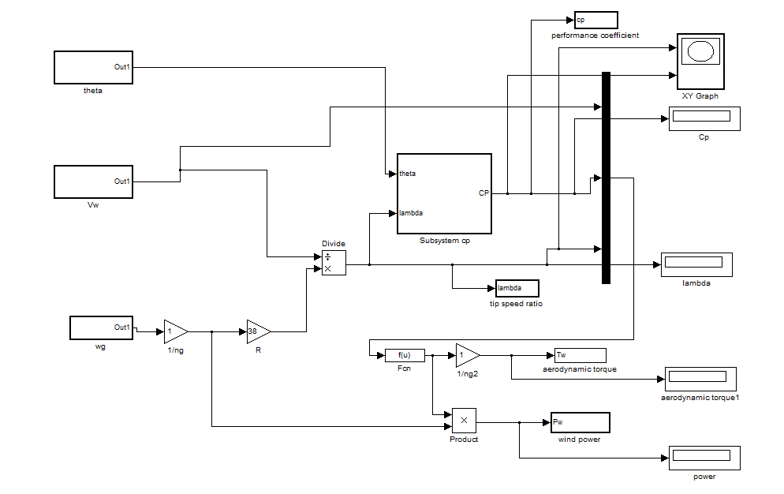
Fig.8.1. wind turbine modeled with simulink.
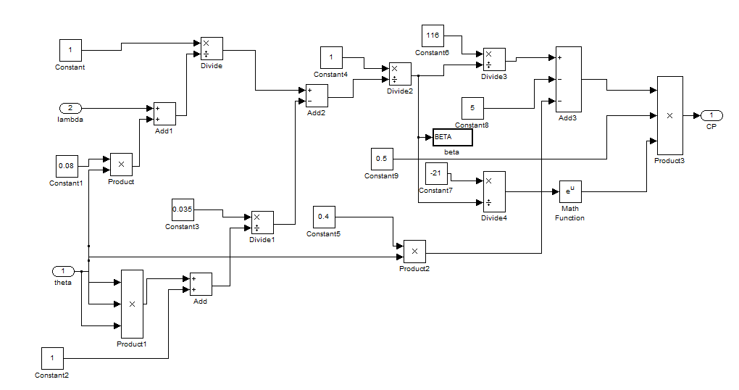 Fig 8.2.Subsystem In Wind Turbine Model To Calculate Cp Value

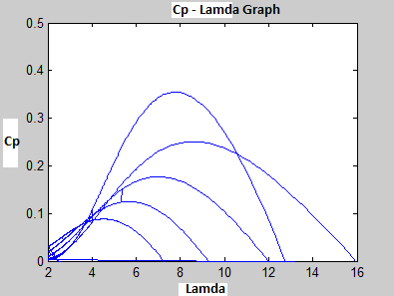
Fig 8.3. C_{p}(Λ, Ө) Characteristics Of Wind Turbine

8.5 Power Speed Characteristics:
The mechanical power that can be extracted from the wind depends heavily on the wind speed, and for each wind speed there is always an optimum turbine speed at which the wind power extracted at the shaft of the turbine is maximum, at any other speed apart from this optimum speed we get sub-standard operation of the system. So our chief goal would be to find out the optimum turbine speed over the operational range of the wind stream speeds. This thing is basically area specific, because the wind speeds would vary from place to place. Now the mechanical power transmitted at the shaft is:
P=0.5C_{p} AρV_{w}³
As we know Cp is a function of the Tip Speed Ratio (TSR) & the pitch angle. For a wind turbine with radius R, the above formula can be written as,
P=0.5Cp πR²ℓV_{w}³
Now as the TSR, λ= ωR/V_{w}
The maximum value of the shaft power output for any wind speed can be expressed as:
P_{m}=0.5Cp π (R⁵/λ³) ω³ℓ
P_{m} α ω³
8.6 Torque Speed Characteristics
Now we know that the Torque and power curves are related as follows:
Tm= Pm/ω
Using the above value for P_{m}=0.5Cp π (R⁵/λ³) ω³ℓ

We have,
T_{m}= P_{m}/ω
T_{m}=0.5Cp π (R⁵/λ³) ω²ℓ
It is seen that at the optimum operating point on the C_{p}- λ curve, the torque is quadratic ally related to the rotational speed.

Tip speed Ratio
The tip speed ratio (TSR) of a wind turbine is defined as,
λ= 2πRN/V_{w} V_{w} = Speed of Wind without any rotor intervention
R=Radius of the Rotor, which signifies the swept area
N=Rotational speed of the rotor in r.p.s
λ= Tip Speed Ratio
The tip speed ratio (λ) for wind turbines is the ratio between the rotational speed of the tip of a blade and the actual velocity of the wind .It’s basically non dimensional in nature and high efficiency 3-blade-turbines have tip speed ratios of 6–7.

8.7 Power – Speed Characteristics of Variable Speed Wind Turbine:
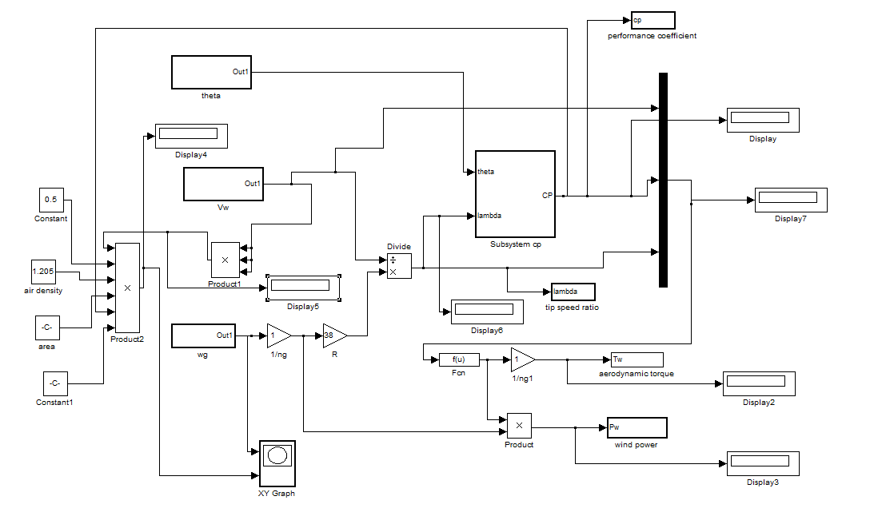
Fig 8.4. power speed characteristics with simulink.
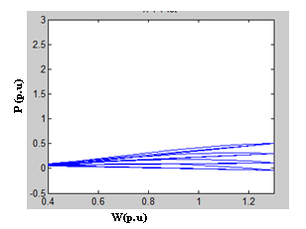
Fig 8.5. Power-Speed Characteristics Of Wind Turbine

- DRIVE TRAIN MODEL

The drive train of a wind turbine generator system consists of the following elements: a blade-pitching mechanism with a spinner, a hub with blades, a rotor shaft and a gearbox with breaker and generator. It must be noted that gearbox is not considered because the analyzed system consists of a wind turbine equipped with a multi-pole PMSG The acceptable (and common) way to model the drive train is to treat the system as a number of discrete masses connected together by springs defined by damping and stiffness coefficients .

Fig 9.1. Transmission model of N masses connected together.

When the complexity of the study varies, the complexity of the drive train differs. For example, when the problems such as torsion fatigue are studied, dynamics from all parts have to be considered. For these purposes, two-lumped mass or more sophisticated models are required. However, when the study focuses on the interaction between wind farms and AC grids the drive train can be treated as one-lumped mass model for the sake of time efficiency and acceptable precision.

The last approximation has been considered in the present study and it is defined by the following equation

where the sub-index g represents the parameters of the generator side, wg is the mechanical angular speed [rad/s] of the generator, Bm is the damping coefficient [Nm/s], T_{e} is the electromechanical torque [Nm], Tw_g is the aerodynamic torque that has been transferred to the generator side, which is equal to the torque produced in the rotor side because there is no gearbox, and Jeq is the equivalent rotational inertia of the generator [kg-m²'], which is derived from

Where Jg and J_{w} are the generator and the rotor rotational inertias [kg-m²] respectively, ng is the gear ratio, which is equal to 1, because no gearbox is utilized.
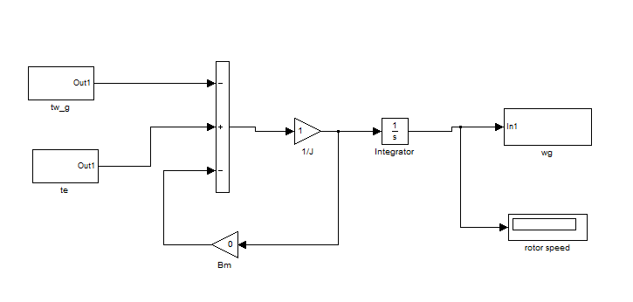
Fig 9.2. Drive Train modeled with Simulink.

- GENERATOR MODELING

10.1 Introduction about generator:
In general, electrical machines play an extremely important role in industry and in our everyday life. Electrical machines generate electrical power in power plants and convert electric power to mechanical power in industrial and consumer applications. If the conversion is from electrical power to mechanical power, the machine is called motor, while in the conversion from mechanical to electrical, the machine is a called a generator.

Conversion of energy is based on two electromagnetic phenomena. First, if a conductor is in a magnetic field and there occurs any change in the magnetic field or the conductor moves, a voltage is induced in the conductor. This phenomenon is generally known as Faraday’s Law. Second, if a charged item, such as a current-carrying conductor, is placed in a magnetic field, the conductor experiences mechanical force. This is known as the Lorentz force. The DC machine, induction machine, and synchronous machine are the common rotating electrical machines.

Generally the output of wind turbine is in mechanical form. So in order get an electric power, we must have a generator arrangement.

Basically there are three types of generating systems are used in wind energy conversion system. Those are,
10.1.1 Squirrel Cage Induction Generator:
- Conventional, directly grid coupled squirrel cage induction generator
- The slip, and hence the rotor speed of a squirrel cage induction generator varies with the amount of power generated.
- These rotor speed variations are, however, very small, approximately 1 to 2 per cent.
- Therefore, this wind turbine type is normally referred to as a constant speed
- Can run at two different (but constant) speeds by changing the number of pole pairs of the stator winding.
- A squirrel cage induction generator always consumes reactive power. In most cases, this is undesirable, particularly in case of large turbines and weak grids.

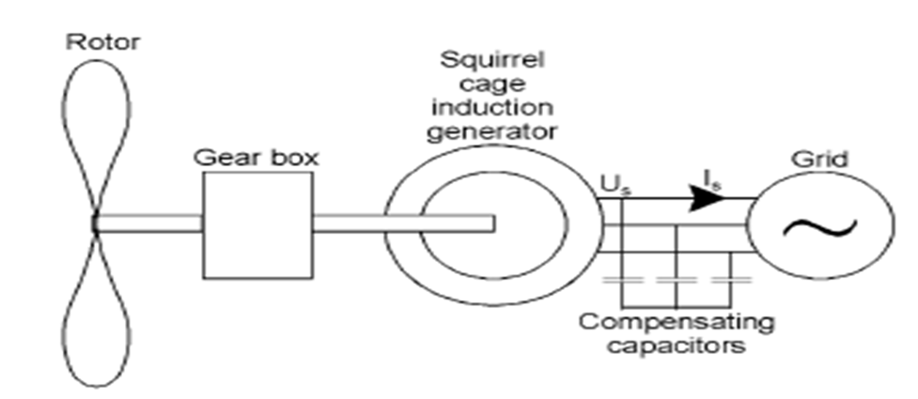
Fig 10.1. Wind Turbine Generating System With Squirrel Cage Induction Generator

10.1.2 Doubly Fed (Wound Rotor) Induction Generator:
- To allow variable speed operation, the mechanical rotor speed and the electrical frequency of the grid must be decoupled.
- In the doubly fed induction generator, a back‐to‐back voltage source converter feeds the three phase rotor winding.
- In this way, the mechanical and electrical rotor frequency is decoupled and the electrical stator and rotor frequency can be matched, independently of the mechanical rotor speed.
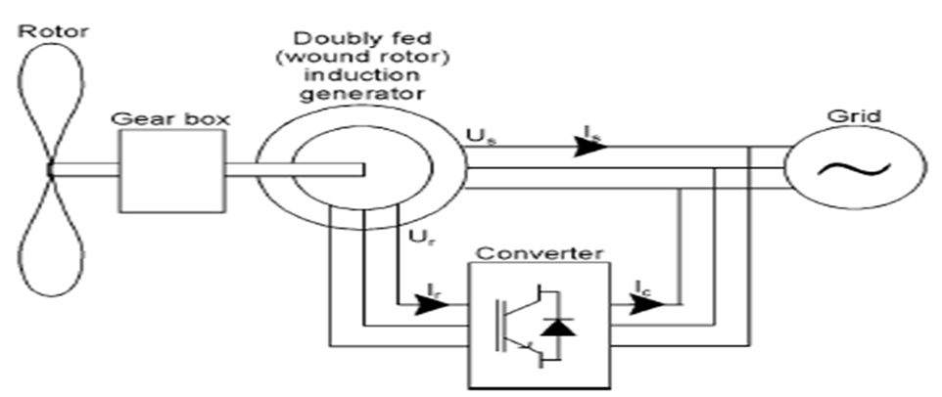
Fig10.2. Wind Turbine Generating System With Doubly Fed Induction Generator

10.1.3 Direct Drive Synchronous Generator (PMSG):
- In the direct drive synchronous generator, the generator is completely decoupled from the grid by a power electronics converter.
- Here we don’t need a gearbox gear box arrangement, why because PMSG is used for low speed variable speed applications. So the net weight of wind turbine is reduced.
- More reliable insulation - fewer repairs, higher availability
- Modularity facilitates repairs and lowers repair cost.
- Lower copper losses.
Fig10.3. Wind turbine generating system with PMSG

10.2 Introduction about PMSG:
In rotating electrical machines the magnetic circuits are formed by ferromagnetic materials in conjunction with air as a medium. The magnetic field is typically produced by feeding electric current through coils that are wound around ferromagnetic materials. In permanent magnet synchronous machines the permanent magnets are the major source of magnetic flux. A permanent magnet is capable of maintaining a magnetic field without any excitation current linkage provided to it. The first commercial versions of industrial permanent magnet synchronous machines emerged in the early 1980s.
Permanent magnet generator drives with frequency converters rated up to 5 MW and more are emerging in wind power plants. For instance, the Finland-based electrical consortium of Rotatek Finland Ltd, Verteco Ltd (nowadays The Switch) and Vaasa Engineering Ltd has successfully supplied electrical systems for the Norwegian Also General Electric has successfully tested a 2.5 MW permanent magnet wind turbine, and the company will be manufacturing both 2.5 MW and 3 MW wind turbine designs in the future. Siemens also reports that they 5MW offshore wind generators in the production. These are some of the largest wind turbine units in the world when measured by the generated electricity. An example of a gearless permanent magnet generator by Siemens for wind turbines is shown in Fig. 5.4

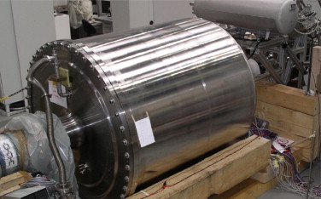
Fig 10.4. Siemens 4 MW HTS rotor test bench (Siemens picture).

The permanent magnet synchronous machine can be electrically described in steady-state using a simple equivalent circuit with an armature equation including back electromotive forces (emf’s). This model assumes that saturation is neglected, the induced emf’s are sinusoidal, the Eddy currents and hysteresis losses are negligible, and that there are no field current dynamics.

The dynamic model of the PMSG is derived from the two phase synchronous reference frame, which the q-axis is 90° ahead of the d-axis with respect to the direction of rotation. The synchronization between the d-q rotating reference frame and the abc-three phase frame is maintained by utilizing a phase locked loop (PLL) Fig.5.5 shows the d-q reference frame used in a salient-pole synchronous machine (which is the same reference as the one used in a PMSG), where e is the mechanical angle, which is the angle between the rotor d-axis mechanical angle, which is the angle between the rotor d-axis and the stator axis.

Fig10.5. d-q and α-β axis of a typical salient-pole synchronous machine.

10.3 Mathematical Model of PMSG:
The equations describing a synchronous generator can be found in. It is beyond the scope of this text to present a detailed treatment of the synchronous generator. A brief overview is however provided, in order to present the most important features of the permanent magnet synchronous generator (PMSG) used in wind turbines. The equivalent circuit for one phase of synchronous generator is shown in Figure5.6.

Fig 10.6. Equivalent circuit and phasor diagram of a PMSG.

Synchronous machine models for power system analysis are usually based on the assumption that the magnetic flux distribution in the rotor is sinusoidal. With this assumption the flux can entirely be described by a vector and in the case of PMSG, the magnetic fields from the permanent magnets induces a voltage E in the stator winding, expressed as:
Where ωe is the electrical speed, ψ_{PM} is the magnitude of the flux induced in the stator by the permanent magnets of the rotor, and fe, is the electrical frequency. A current Is in the stator winding causes losses and voltage drop, both phenomena are represented in the model by the resistance Rs. Apart from causing resistive voltage drop, the stator current also produces a magnetic field of its own, which is added to the field generated by the permanent magnets. Thus, the voltage Us at the stator terminal of PMSG corresponds to the voltage induced by the total magnetic field. Depending on the phase delay of the stator current, the total magnetic field in the generator either increases or decreases as the current increases. This effect is represented by the synchronous reactance Xs in the model. The resistance Rs is normally much smaller than Xs, and therefore it is normally neglected except in efficiency calculations. It can be found in and that multi-pole synchronous generators are characterized with a relatively high stator reactance. The load angle δ between the internal voltage E and the stator voltage Us drives the stator current Is. The relationship among E, Us and Is is shown in the phasor diagram of Figure 5.6. Note that the induced voltage E is proportional with the electrical speed of the generator. When E < Us it is said that the machine is under excited, otherwise it is over excited. The electrical excited machines are typically controlled to be reactive neutral, i.e. the converter rating is reduced to the active power value. The permanent magnet generators due to their fixed excitation, work typically under excited, i.e. the converter provides reactive power to the generator and therefore the converter must be oversized. Based on this, the expressions of the active and reactive power of the generator in terms of E, Us and the load angle δ can be derived:
If the mechanical power input increases, i.e. the load angle (the phase shift between Us and E) increases, the electrical power output increases also, reaching a maximum at δ = 90º. The converter is able to generate or absorb active and reactive power, if both the load angle and voltage magnitude are controllable. The equations of a PMSG can be expressed directly from the equations of a DC excited synchronous generator, with the simplification that PMSG does not have damper winding. The steady state voltage equations of the generator, expressed in the rotor-oriented dq-reference frame RRF can be expressed as follows:

With the stator flux components:
Where u_{sd} and u_{sq} are the terminal stator voltages, i_{sd} and i_{sq} are the stator currents, L_{d} and L_{q} are the stator inductances in the dq reference frame. In stability studies, where the stator transients can be neglected, the stator voltage equations can be reduced to
And the stator current equations of PMSG are,

In the above current equations W_{e} is the electrical rotating speed [rad/s] of the generator, defined by,
,
Here P is the no. of pole pairs.
Expressing further the stator flux components, the electrical torque can be calculated y:
The active and reactive power of the synchronous generator can be then expressed as,

In the case of variable speed wind turbines, the active and reactive powers of the generator are controlled by the converter, which acts on the generator stator voltage and current. As the generator is fully decoupled from the grid by the converter, the reactive power expressed previously is exchanged with the generator-side converter and not with the grid.

The PMSG has no damper windings. As a PMSG is connected to the grid through a converter, which provides a variable stator frequency according to the actual rotor speed, there is never any relative movement between stator and rotor field, which could induce a voltage in the damper winding. Furthermore, due to the permanent excitation, a PMSG has no field windings, in which transient currents could be induced or damped, respectively. Hence, in case of transients the field windings do not contribute to damping either. The PMSG connected to a converter is thus a system without inherent damping. Nevertheless, an external damping of the system must then be applied by means of the converter control.

10.4 PMSG modeled with simulink:

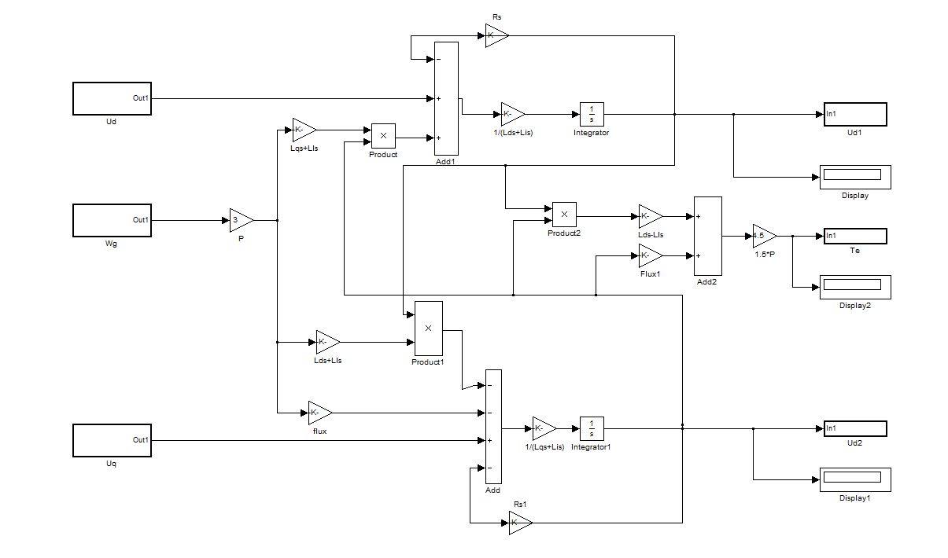
Fig 10.7.PMSG modeled with simulink

10.5 Detailed model of a variable-speed PMSG wind turbine:

Fig 10.8. Detailed model of a modern variable-speed direct- driven PMSG wind turbine

The power conditioning system (PCS) used for connecting renewable energy sources to the distribution utility grid requires generation of high quality electric power, being at the same time flexible, efficient and reliable. Fig.5.7 shows the detailed model of a modern direct-in-line variable-speed direct-driven PMSG wind turbine connected to the utility distribution grid, which is composed of a back-to-back AC/DC/AC power converter that fulfills all the requirements mentioned above. Since the permanent magnet synchronous generator produces an output voltage with variable amplitude and frequency, additional conditioning is required to meet the amplitude and frequency requirements of the roughly stiff utility grid.

A three-phase uncontrolled full-wave rectifier bridge is proposed here for performing the AC/DC conversion. This device has the benefit of being simple, robust, cheap, and needs no control system. On the other hand, a three-phase three-level DC/AC voltage source inverter (VSI) using IGBTs is employed for connecting to the grid. As the power rating of the inverter is lesser than a few MWs, the output voltage control of the VSI can be achieved through pulse width modulation (PWM) techniques. This power inverter topology is proposed above other ones because generates a more sinusoidal output voltage waveform than conventional structures without increasing the switching frequency. In this way, the harmonic performance of the inverter is improved, also obtaining better efficiency and reliability respect to the conventional two-level inverter topology.

The connection to the utility grid is made through a step-up transformer and a low pass filter in order to reduce the perturbation on the distribution system from high-frequency switching harmonics generated by the PWM control. As the VSI needs a fixed DC link in order to allow a decoupled control of both active and reactive power exchange with the electric grid, an interface in the DC side of the VSI is required. For this purpose, an intermediate DC/DC converter in a boost topology is used, linking the output of the full-wave rectifier bridge to the DC bus of the power inverter. Only one power switching device is used in the DC/DC converter, resulting in a low cost and simple control. This two-stage AC/DC energy conversion system offers an additional degree of freedom in the operation of the system when compared with conventional onstage configurations, permitting to pursue various control objectives simultaneously with the WTG system operation.

11. Conclusions
- The modeling of a variable speed wind turbine with a permanent magnet synchronous generator has been treated.
- The model has been implemented in MATLAB/Simulink in order to validate it. Cp curves have been obtained.
- The generator has been modeled in the d-q synchronous rotating reference frame, taking into account different simplifications.
- The power speed characteristics are obtained by simulating the circuit.

12. Future scope
“Wind turbines shed their gears”
Instead of harvesting the power of the wind at the hub of the turbine, a new design features a direct-drive generator powered by the outside rim of the turbine, and has potential for large-scale offshore wind power installations
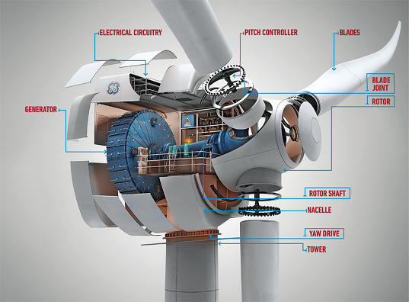
Fig 12.1. Six-Megawatt Direct-Drive Wind Turbine from Siemens

References
- Z. Lubosny. Wind Turbine Operation in Electric Power Systems. Berlin: Springer 2003.
- T. Ackermann. Wind Power in Power Systems. New York: John Wiley & Sons, 2005.
- The American Wind Energy Association (2004, March). Global wind power growth continues to strengthen [Online]. Available: http://www.ewea.org.
- Horns Rev Offshore Wind Farm Technical Report (2007). Available: http://www.homsrev.dk.
- M. Yin, G.Li, M. Zhou and C. Zhao. “Modeling of the wind turbine with permanent magnet synchronous generator for integration”. IEEE Power Engineering Society General Meeting, Tampa, Florida, 2007, pp. 1-6.
- J. G. Slootweg, S. W. H. de Haan, H. Polinder and W. L. Kling. “General Model for Representing Variable Speed Wind Turbines in Power System Dynamics Simulations”. IEEE Transactions on Power Systems, vol. 18, no. 1, 2003.
- P. M. Anderson and A. Bose. “Stability Simulation of Wind Turbine Systems”. IEEE Transactions on Power Apparatus and Systems, vol. PAS-l02, no. 12, 1983.
- S. Heier, Grid Integration of Wind Energy Conversion Systems. New York: John Wiley & Sons, 1998.
- J. L. RodrIguez, J.C. Burgos and L. Amalte. Sistemas Eólicos de Producción de Energia Eléctrica. Madrid: Editorial Rueda S.L, 2003.
- C. Krause. Analysis of electric machinery. 2nd Edition. United States of America: Willey, 2002.
- G. Ramtharan and N. Jenkins. “Modelling and Control of Synchronous Generators for Wide-Range Variable-speed Wind Turbines”. Wind Energy, Wiley Interscience, vol. 10, pp. 231-246, March 2007.
- M. Chinchilla, S. Arnaltes and J. C. Burgos. “Control of Permanent­ Magnet Generators Applied to Variable-Speed Wind-Energy Systems Connected to the Grid”. IEEE Transactions on Energy Conversion, vol. 21, no. 1, 2006.
BASE PAPER: Alejandro Rolan', Alvaro Luna, Gerardo Vazquez, Gustavo Azevedo.Daniel Aguilar Modeling of a Variable Speed Wind Turbine with a Permanent Magnet Synchronous Generator: Seoul Olympic Parktel, Seoul, Korea July 5-8, 2009

